Introduction to NLP and LLMs: Principles and Practical Applications
Concept Application:
Multimodal allow the LLM to interpret the radar, video, and sensor on the dogs paired with natural language commands, treating vision and language into one. Retrieval augmented generation would allow us to connect the LLM to live data, such as asset records, maintenance logs, and history so reports can stay current. Domain-specific fine tuning would allow us to teach the model telecommunication and construction terminologies in site-specific hazards. The project overall fits the Agentic AI concept where the dog would need autonomy to be able to navigate, judge a hazard, and adapt to real-time sensor input. Given that the dog’s intended use is in underground areas where connection is lacking, IoT integration matters in being able to run lightweight components on the device. Lastly, since the robot dog would be working near people in dangerous settings, setting responsible guardrails on the Ai, such as safety filtering, reliability testing, and clear accountability, are important.

What is Natural Language Processing (NLP)
NLP is a field of Artificial Intelligence (AI) focused to enable computers translate, interpret, summarize and analyse the human language meaningfully:
- Allows language to have a sense of language and tone
- Help applications respond better to human needs and interactions

Why should we Process Text Data?
Computers cannot process natural language, so usually humans pre-process it. Steps are shown below:
- Tokenization: breaking down text into individual words
- Removing stop words: Eliminating common words that don’t carry significant meaning
- Lowercasing: Converting text to lower case
- Stemming/lemmatization: Reducing words to root form
- Part-of-speech (POS) tagging: Identifying grammatical role in each sentence such as determining whether is it a noun verb or adjective?
- Entity extraction: extracting entities including nouns, locations, and etc.
- Vectorization/embeddings: converting text into numerical vectors that capture semantic relationships between words

Challenges and limitations of NLP:
- Basic NLP handles tasks well but struggle to come up with context coherent appropriate responses without extensive rule-based templates
- Basic NLP can extract basic information, but fail to do so in specific situations such as in medical records that would require the NLP to understand medical terminology, context, and specific information relationships such as what are the symptoms related to that diagnosis

UNDERSTANINDG LLMS
- LLMs have the ability to extract insights from vast amts of data including structured data like tables and converting it to textual information
- LLMs directly analyse nuances of unstructured text data
- LLMs are strong because they are trained to large data sets that are diverse, including, text, code images audio and video from various sources
Key capabilities of LLMs:
Core language tasks:
- Text generation
- Summarization
- Language translation
- Question answering
- Names entity recognition
- Sentiment analysis
Multimodal tasks:
- Text to speech
- Text to image
- Image to image
- Speech to text
Other important applications:
- Code generation
- Chatbots/conversational ai
LLMs are a subset of ai

KEY ELEMENTS OF LLMS
Foundation and training:
- LLMs get power from training on large datasets
- Data preparation is important but not always extensive depending on the use case
- Training data feeds into a foundation model built with deep idea
- LLMs are integrated with other systems where they can indirectly access and use info from databases, APIs, and other live data sources
How LLMs work:
- Using an LLM is like writing a prompt for a task
- The model will interpret the prompt, apply the pattern it learns to generate a response
Incorporating custom data:
- Fine tuning
- Further training a pretrained foundation model on specific datasets to adapt it to the use case
- Prompt engineering w/ context
- Feeding relevant data directly into the prompt to give the model necessary context without needing to retrain
Retrieval Augmented Generation
- LLMs can connect to external live data sources
- Without thus augmentation, the responses would stay generic
Accuracy method sin LLMS:
- Grounding
- Data augmentation
- Prompt engineering
- Retrieval augmented generation
- Fine tuning
LLM Hallucination
- Where they fabricate information

INDENTIFYING OPPORUTNITEIS FOR NLP AND LLM
Customer service
- Improve support across chat by understanding customer language and analysing sentiment
- Sentiment analysis: allows organizations to monitor social media feedback in real time and gauge public opinion
- Automated chatbots: support customer engagement by communicating directly with customers
- Support ticket management: enhances through automated routing and prisonisations- faster response times, better efficiency, higher satisfaction
Personalized marketing:
- NLP analyses customer data to understand individual Preferences
- LLM use that analysis to generate targeted context
- Extracting key points from long docs to produce consider engaging marketing copy
Team productivity:
- NLP/LLM can automatically tag, categorize, and summarize files
Compliance and risks:
- NLP and LLMs support compliance by analysing docs, monitoring comms, and identifying risks
- Fraud detection: NLP handle basic detection while LLMs add nuanced languages context for more sophisticated schemes
- Regulatory compliance: LLMs monitor for regulatory changes, NLP extracts key info form legal text, ensures consistency and flag compliance gaps
- Financial risk assessment: extracts financial data while LLMs analyse sentiment and correlate risk factors

QUANITFYING THE POTENTIAL ROI OF NLP AND LLM PROJECTS
Why ROI Matters:
- ROI or return of Investment is a metric that measures the value in justifying in NLOP/LL< projects
- It measures how effectively these techs contribute to the goals such as cost reduction, revenue growth and productivity gains
Tips for Measuring ROI:
- Collect baseline data
- Trach relevant metrics
- Analyse quantitative data
- Continuously monitor and optimize

BUILDING A BUSINESS CASE FOR NLP AND LLM INITIATIVES
Core framework:
- Define the problem statement
- Connect strategic objectives
- Propose the solution
- Address risks upfront
- Quantify ROI
- Present financial case

USE CASES AND CASE STUDY
NPL Use Case Examples:
Text Classification | Chatbots and Virtual Assistants | Question Answering Systems | Automatic Speech Translation
Sentiment Analysis | Speech Recognition | Sentiment and Emotion Detection in social media | Legal Doc Review
Machine Translation | TTS | Customer Feedback Analysis | Healthcare Applications
Named Entity Recognition | Document Classification and Automation | Market Intelligence | Frade Detection
Text Summarization | Search and Information Retrieval | Plagiarism Detection | Personalized Recommendations

LLM Use Case Examples:
Content generation | Customer support automation | Language translation | Summarization | Code generation and debugging
Sentiment analysis | Knowledge management and Q&A | Personalized Recommendations | Healthcare applications | Legal document analysis
Education and tutoring | Virtual assistants | Financial analysis | Text-to image or text-to speech generation | Social media monitoring

BIAS AND FAIRNESS IN NLP AND LLMS
Bias in AI: When models Favor specific groups due to flawed training data, such as societal stereotypes
Main 2 sources:
Data imbalances
- Pre=existing bias
Fairness in AI: equitable performance across al user groups, essential for building trust and ensuring ethical use
2 approaches to fairness:
- Demographic parity
- Equal opportunity
Ethical Deployment Requirements:
- Ongoing bias mitigation
- Rigorous data audits
- Continuous post deployment evaluation
- Transparent communication with stakeholders

PRIVACY AND DATA SECURITY
Data security and privacy matter especially when handling sensitive user information because it contains sensitive data making risk for breaches and unauthorized access
Core challenges:
- Handling sensitive data
- Risk of unauthorized access
Privacy Fundamentals:
- Privacy
- The Data lifecycle
  - GDPR (general data protection regulation)
  - CCPA (California consumer privacy act)
- These regulations dictate how data can be acquired, retained, and processed
Privacy Protection Techniques:
- Anonymisation
- Data minimisation
- Data masking
Data security fundamentals:
- Safeguards data against unauthorized access, breaches, loss and corruption
- Protects confidentiality integrity and availability of sensitive information

Data security Techniques:
- Encryption
- Access Controls
- Regular Monitoring
Best Practices:
- Investigate privacy measures into every project phase
- Invest in monitoring tools
- Foster user trust through clear communication

RESPONSIBLE AI PRACTICES
6 key components:
- Fairness
- Transparency
- Accountability
- Privacy
- Reliability
- Safety
Applying Responsible AI to the LLM lifecycle:
- Bias mitigation
- Privacy
- Transparency
- Data policy
- Security
- Robustness
- Monitoring
- User-facing transparency
- User communication
Guardrails:
Mechanism that constrains LLM behaviour to keep it within safety/ethical boundaries
- Input guardrails: filter our harmful prompts before it reaches the model
- Output guardrails: catch harmful biased responses before they reach the user

KEY ROLES IN NLP/LLM TEAM
Key roles in a team:
- Data scientists:
  - Build the model
  - Collaborate with stakeholders
- Machine learning engineers
  - Take models built and prepare for production
  - optimizer
- Data engineers
  - Build and maintain data pipeline
  - Feed training data
- Domain experts
  - Provide contextual subject matter knowledge
- Project managers
  - Oversee scop, timelines budget and team coordination
- Ai ethics specialist
  - Ensure responsible ai usage

TEAM ESSENTIAL SKILLS AND COMPETENCIES
- AI Ethics Specialist
  - Ethical principles
  - Bias detection
  - Risk assessment
- Project Manager
  - Project management methods
  - Communication
  - Technical understanding
- Domain Experts
  - Domain expertise
  - Ethical considerations
- Data Engineers
  - Big data tech
  - Data pipelines
  - Etl processes
  - Database management
- ML Engineers
  - MLOps programming
  - Model optimization
  - deployment
- Data Scientist
  - Deep learning
  - LLM fundamentals experimentation
  - Data quality
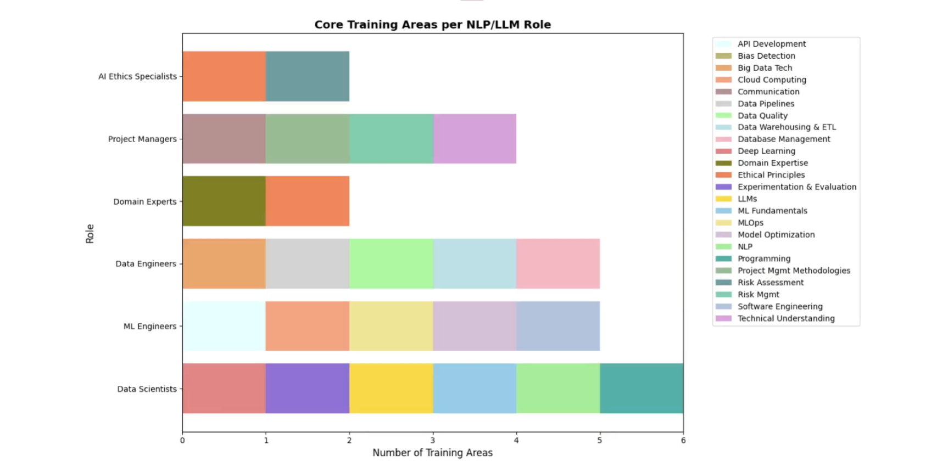

TEAM COLLABORATION TREE
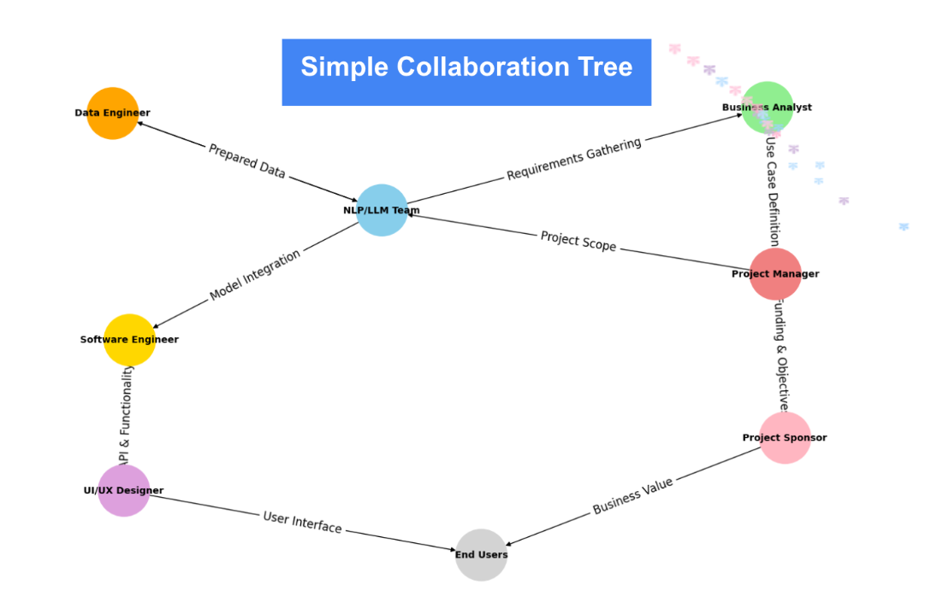
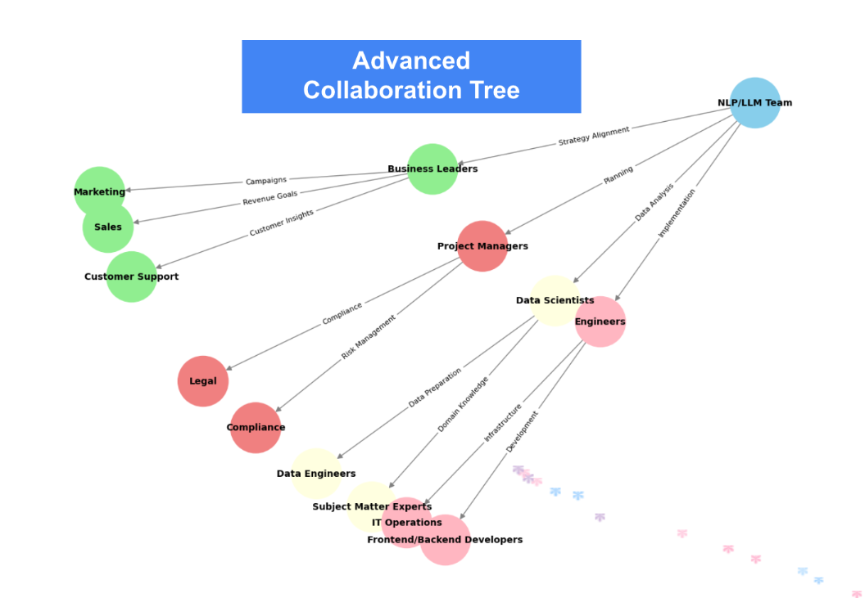

PROEJCT MANAGEMENT AND EXECUTION
Project phases:
- Initiation
  - Define objectives
  - Create project charter
  - Form team
- Planning
  - Build detailed timeline
  - Allocate budget
  - Define roles and responsibilities
- Execution
  - Build it
  - Conduct progress reviews
  - Address issues
  - Train stakeholders
- Closing
  - Hand over final product

METRICS FOR MODEL DEPLOYMENT AND EVALUATION
- Deployment metrics: operational performance and reliability
- Evaluation metrics: focus on accuracy, business impact, and user satisfaction
Deployment Metrics:
- Uptime
- Response Time
- Integration Success
Evaluation Metrics:
- Accuracy metrics
- Business impact metrics
- User satisfaction metrics
Key takeaway:
- Effective deployment integrates models into business operations
- Evaluation ensures models deliver measurable business outcomes
- Continuous improvement keeps models aligned with organization goals
- ROI maximised!

THE EVOLVING LANDSCARE OF NLOP AND LLMS
Predicted Future trends:
- Domain specific fine tuning
- Multimodal and advanced conversational agents
- Improved explainability and transparency
- Agentic AI
- Real-time language translation and specialized efficient LLs
- IoT and edge device integration
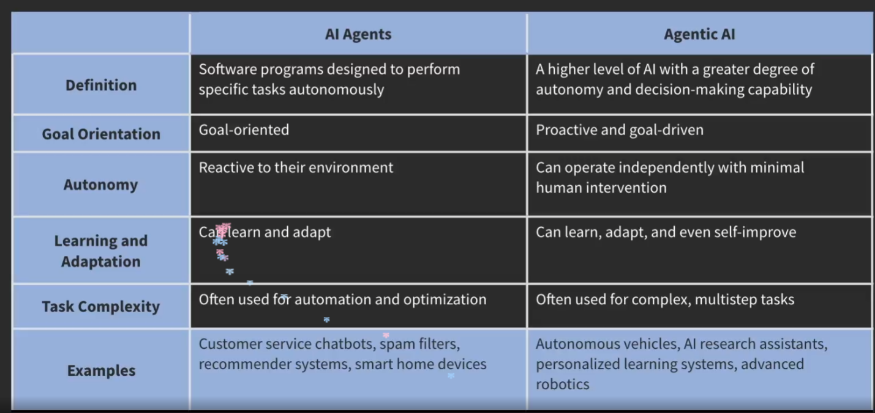
Practical Applications:
- AI Agents
  - FAWQ assistance
  - Task automation
  - Data extraction/parsing
  - Basic workflow management
- Agentic AI
  - Autonomous customer service
  - Personalized healthcare
  - Smart manufacturing
  - Disaster response
Additional New Frontiers
- Quantum NLP
- Neuromorphic NLP

INDUSTRIES EXPERIENCING SIGNIFICANT TRANSFORMATIONS
- Advertising and marketing
- Agriculture
- Automotive
- Customer service
- Education
- Energy
- Finance
- Government
- Heartcare
- Human resources
- Legal
- Manufacturing
- Media and entertainment
- Real estate
- Retail and e-commerce
- Travel and hospitality

PREPARE FOR THE FUTURE: BUILD A NLP/LLM STRATEGY
- Define business objectives
- Identify specific use cases
- Conduct a data assessment
- Select technology
Strategic priorities for success:
- Robust data strategy
- Employee training
- Starting small
- collaboration

